PROJECT EXPO-26
PHASE 5: Testing & Validation Review (TVR)

SECURE MOBILE WEB-BASED REMOTE VOTING SYSTEM

Team Members: Vaishika T.A, Ezhilvizhi R,
Babykarthika S

1. PROJECT OVERVIEW
The Secure Mobile Web-Based Remote Voting System is a web-based voting platform designed to enable registered representatives to participate in elections remotely using a mobile device or computer.
The system provides authenticated login, candidate/NOTA selection, vote validation, duplicate-vote prevention, secure vote recording, election monitoring, statistics, and result presentation through an admin dashboard.
The purpose of Phase 5 is to test and validate the developed prototype and identify functional issues, performance limitations, reliability concerns, and possible future improvements.

TESTING ENVIRONMENT
The prototype was tested using a web browser on a computer/mobile device.

Hardware Environment
Component | Details
Computer/Laptop | Used for development and testing
Mobile Device | Used to verify mobile accessibility
Internet Connection | Required for accessing the deployed web application

Software Environment
Software/Platform | Purpose
Web Browser | Accessing and testing the application
Bolt.new | Web application development
GitHub | Source-code and documentation management
Supabase | Database/backend services used by the application
Deployed Web Application | Functional prototype testing

FUNCTIONAL TESTING REPORT
Functional testing was carried out to verify whether the major modules of the voting system operate according to the intended workflow.
Test ID | Function Tested | Expected Result | Actual Result | Status
FT-01 | Open voting website | Home page should load successfully | Opened successfully | PASS
FT-02 | Voter login with valid credentials | Voter should be authenticated and taken to the voting interface | yes | PASS
FT-03 | Voter login with invalid credentials | System should reject invalid login details | yes | PASS
FT-04 | Display election information | Active election and available candidates should be displayed | Yes displayed | PASS
FT-05 | Candidate selection | Voter should be able to select a candidate | Can choose a candidate | PASS
FT-06 | NOTA selection | Voter should be able to select NOTA | NOTA option is also added | PASS
FT-07 | Vote confirmation | Selected option should be confirmed before submission | A confirmation menu will appear | PASS
FT-08 | Vote submission | Vote should be recorded successfully | Recorded successfully | PASS
FT-09 | Duplicate vote prevention | Previously voted representative should not be allowed to vote again | Only one vote for one voter | PASS
FT-10 | Admin login | Authorized administrator should access the dashboard | Admin can use | PASS
FT-11 | Admin dashboard | Voting statistics and election information should be displayed | Displayed | PASS
FT-12 | Election results | Results should be displayed correctly | Displayed results are true | PASS
FT-13 | Logout | User/admin session should be terminated | Terminated | PASS
FT-14 | Mobile accessibility | Website should be usable on a mobile device | Used in mobile also | PASS

Functional Testing Summary
The functional testing focused on the major voter and administrator workflows. The tests covered authentication, voting, vote validation, duplicate-vote prevention, administration, statistics, and results.
Any failed or partially implemented functions identified during testing are documented in the Error Analysis and Debugging Report sections.

PERFORMANCE EVALUATION
Performance evaluation was conducted to assess the responsiveness and usability of the web-based voting system under normal testing conditions.
The following parameters were considered:
- Page loading and navigation
- Login response
- Voting page responsiveness
- Vote submission response
- Admin dashboard loading
- Results display
- Mobile accessibility
- Database response
Parameter | Observation | Evaluation
Home Page Loading | Works | Good
Login Response | Works | Good
Voting Page Response | Works | Good
Vote Submission | Works | Good
Admin Dashboard | Works | Needs improvement
Results Display | Works | Average
Mobile Usability | Works | Good

Performance Evaluation Conclusion
Under normal prototype testing conditions, the system was evaluated for responsiveness, navigation, and interaction. Further performance testing under larger numbers of simultaneous users is required before considering the system suitable for real-world large-scale elections.

TEST CASES

The following test cases were prepared to validate the important operations of the voting system.
Test Case 1 – Valid Voter Login
Test Case ID: TC-01
Objective: Verify that an authorized voter can log in.
Procedure:
- Open the voting website.
- Select the voter/representative login option.
- Enter valid login details.
- Select Login.
Expected Result:
The system should authenticate the representative and display the appropriate voting interface.
Actual Result: It displayed the appropriate voting interface
Status: PASS

Test Case 2 – Invalid Voter Login
Test Case ID: TC-02
Objective: Verify that invalid login details are rejected.
Procedure:
- Open the voter login page.
- Enter an invalid ID or password.
- Select Login.
Expected Result:
The system should reject the login attempt and display an appropriate error message.
Actual Result: AN error message “Invalid username and password “ will appear
Status: PASS

Test Case 3 – Candidate Selection
Test Case ID: TC-03
Objective: Verify candidate selection.
Procedure:
- Login as an authorized voter.
- Open the active election.
- View the available candidates.
- Select one candidate.
Expected Result:
The selected candidate should be clearly indicated.
Actual Result: Clearly indicated
Status: PASS

Test Case 4 – NOTA Selection
Test Case ID: TC-04
Objective: Verify NOTA selection.
Procedure:
- Open the voting interface.
- Select NOTA.
- Review the selection.
Expected Result:
NOTA should be selectable as an alternative voting option.
Actual Result: It also Works properly
Status: PASS

Test Case 5 – Vote Submission
Test Case ID: TC-05
Objective: Verify that a confirmed vote can be submitted.
Procedure:
- Select a candidate or NOTA.
- Review the selection.
- Confirm the vote.
- Submit the vote.
Expected Result:
The vote should be recorded and a confirmation message should be displayed.
Actual Result: A message with confirm your vote displays.
Status: PASS

Test Case 6 – Duplicate Vote Prevention
Test Case ID: TC-06
Objective: Verify one-person-one-vote enforcement.
Procedure:
- Login using a representative account that has already submitted a vote.
- Attempt to vote again.
Expected Result:
The system should prevent another vote from being submitted by the same representative.
Actual Result: It won’t allow
Status: PASS

Test Case 7 – Admin Dashboard
Test Case ID: TC-07
Objective: Verify administrator access and dashboard functionality.
Procedure:
- Open the administrator login.
- Enter valid administrator credentials.
- Open the dashboard.
- Review election information and statistics.
Expected Result:
The administrator should be able to access the dashboard and view the available monitoring information.
Actual Result: Yes, possible
Status: PASS

Test Case 8 – Election Results
Test Case ID: TC-08
Objective: Verify that election results are displayed.
Procedure:
- Open the results section.
- View candidate-wise voting information.
Expected Result:
The system should display the available election results and voting statistics.
Actual Result: Voting results will be displayed
Status: PASS

ERROR ANALYSIS

During prototype development and testing, possible errors and limitations were analyzed based on the observed behavior of the application.
Error ID | Area | Error/Issue Observed | Possible Cause | Severity | Current Status
EA-01 | Authentication | Error appeared | Authentication/session handling | High | Resolved
EA-02 | Voting | Error appeared | Vote validation/database logic | High | Resolved
EA-03 | Database | Error appeared | Database/query handling | [ow | Resolved
EA-04 | UI | Error appeared | Responsive design/interface | [ow | Resolved
EA-05 | Results | Error appeared | Data calculation/display | Low | Resolved

Error Analysis Conclusion
The prototype was analyzed for errors in authentication, voting, database interaction, user interface, and result processing. Issues identified during testing should be documented with their actual symptoms and corresponding corrective actions rather than assuming or inventing errors.

DEBUGGING REPORT
Debugging was performed to identify and correct issues encountered during the development and testing of the voting system.
Debugging Process
The following general debugging procedure was followed:
Problem Identification
↓
Reproduce the Issue
↓
Check Application Logic
↓
Inspect Database/API Interaction
↓
Identify Root Cause
↓
Apply Correction
↓
Retest the Function
↓
Verify the Result

Debugging Conclusion
The debugging process helped identify issues in the prototype and improve the stability and functionality of the implemented modules. Remaining issues will be addressed during subsequent development.

. RELIABILITY TESTING
Reliability testing was considered to evaluate whether the system performs consistently during repeated operations.
The following operations were considered:
- Repeated login attempts
- Repeated navigation between pages
- Candidate/NOTA selection
- Vote submission
- Duplicate-vote prevention
- Admin dashboard access
- Results viewing
- Logout and re-login
Reliability Test | Procedure | Observation | Status
RT-01 | Repeat voter login | Works | PASS
RT-02 | Repeat page navigation | Works | PASS
RT-03 | Repeat candidate selection | Works | PASS
RT-04 | Attempt duplicate voting | Works | PASS
RT-05 | Repeat admin dashboard access | Works | PASS
RT-06 | Logout and login again | Works | PASS
Reliability Conclusion
The prototype was evaluated through repeated execution of its major workflows. The current testing provides initial evidence of prototype reliability. More extensive testing with larger numbers of users, different devices, browsers, network conditions, and concurrent requests would be required for production-level validation.

10. FUTURE IMPROVEMENTS
The following improvements can be considered for future versions of the Secure Mobile Web-Based Remote Voting System:
- Stronger voter authentication
Additional authentication mechanisms can be considered to improve voter identity verification.
- Enhanced database security
Additional security measures can be implemented to protect election and voting data.
- Improved session management
Stronger session expiration and security controls can be added.
- Better mobile responsiveness
The interface can be further optimized for different screen sizes and mobile browsers.
- Advanced audit mechanisms
Detailed audit logs can be introduced to track important system activities.
- Improved administrator controls
Additional election-management features can be added to the administrator dashboard.
- Scalability testing
The system can be tested with a larger number of simultaneous voters.
- Performance optimization
Database queries, page loading, and backend operations can be optimized.
- Accessibility improvements
Better accessibility features can be added for users with different needs.
- Security testing
More extensive security testing, vulnerability assessment, and penetration testing should be performed before any real-world deployment.
- Automated testing
Automated test cases can be introduced to repeatedly validate critical voting functions.
- Cloud deployment improvements
The system can be further optimized for reliable cloud deployment and scaling.

11. OVERALL TESTING SUMMARY
The Phase 5 Testing & Validation Review focused on evaluating the major functional modules of the Secure Mobile Web-Based Remote Voting System.
Testing covered voter authentication, candidate/NOTA selection, vote submission, duplicate-vote prevention, administrator access, dashboard monitoring, and election results.
The testing process also considered performance, reliability, error analysis, debugging, and future improvements. Since the current implementation is a software/web-based prototype, hardware-related power consumption testing is not applicable.
The prototype has demonstrated the core workflow required for a web-based voting application. Further development and extensive testing are required to improve security, scalability, reliability, and production readiness.

12. TESTING EVIDENCE / SCREENSHOTS
Add screenshots from your actual testing under this section.
Figure 1 – Voting System Home Page
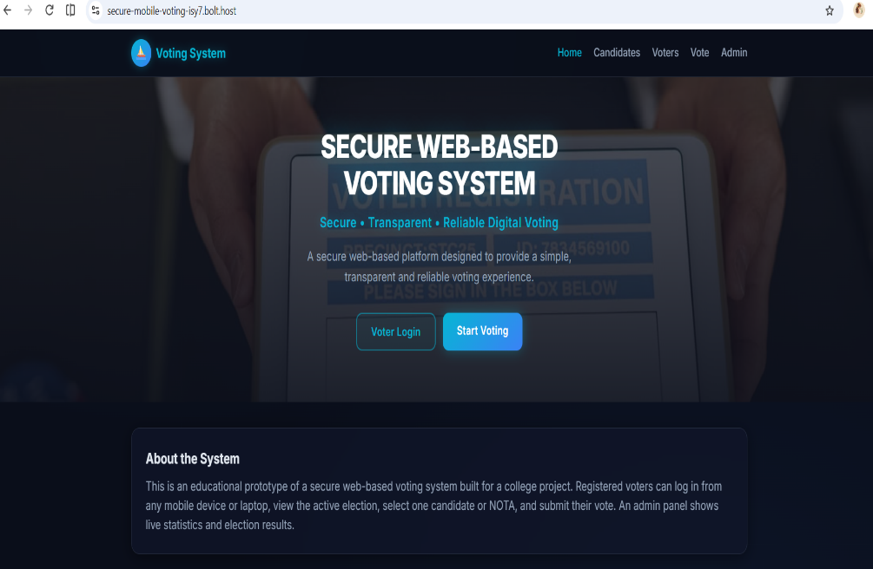
Figure 1: Home page of the Secure Mobile Web-Based Remote Voting System.
Figure 2 – Representative Login
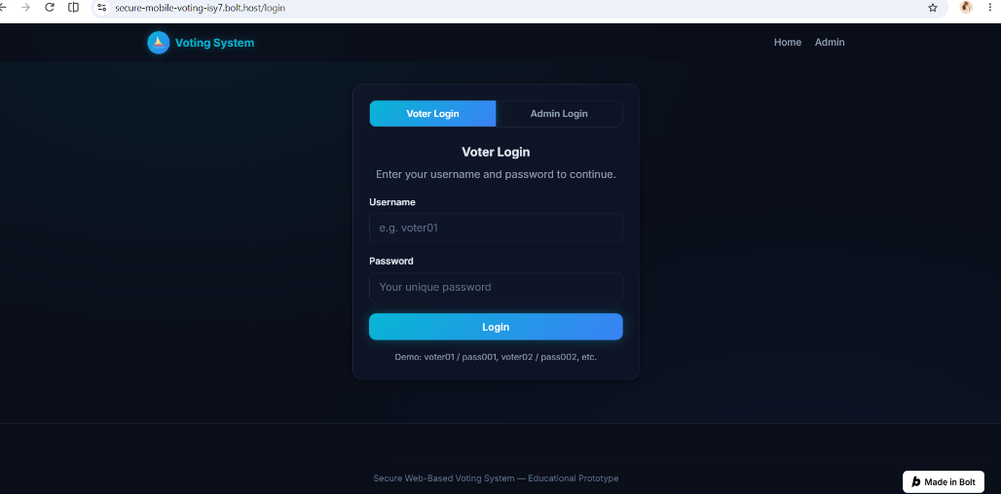
Figure 2: Representative login interface used for voter authentication.

Figure 3 – Voting Interface
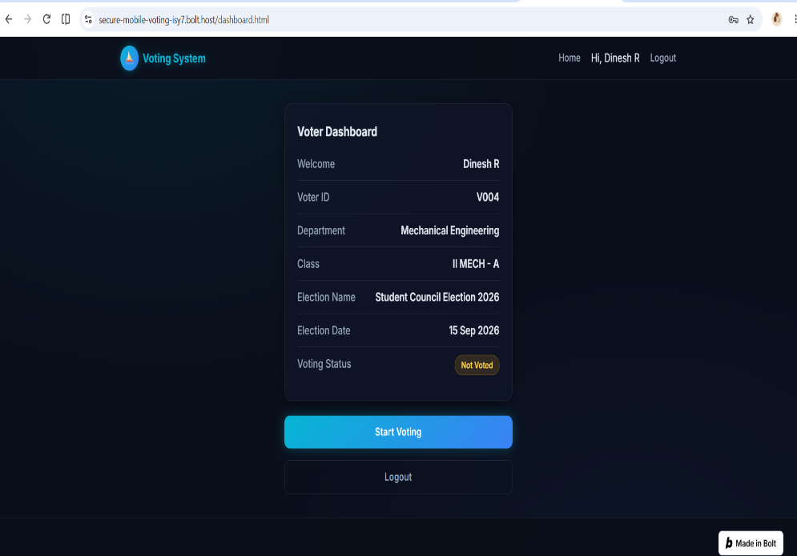
Figure 3: Voting interface displaying the available election and voting options.
Figure 4 – Candidate/NOTA Selection
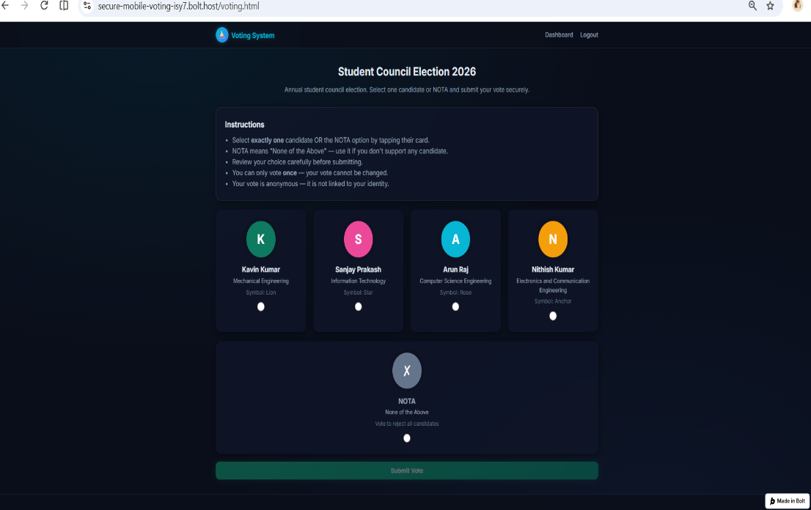
Figure 4: Candidate and NOTA selection interface.

Figure 5 – Vote Confirmation
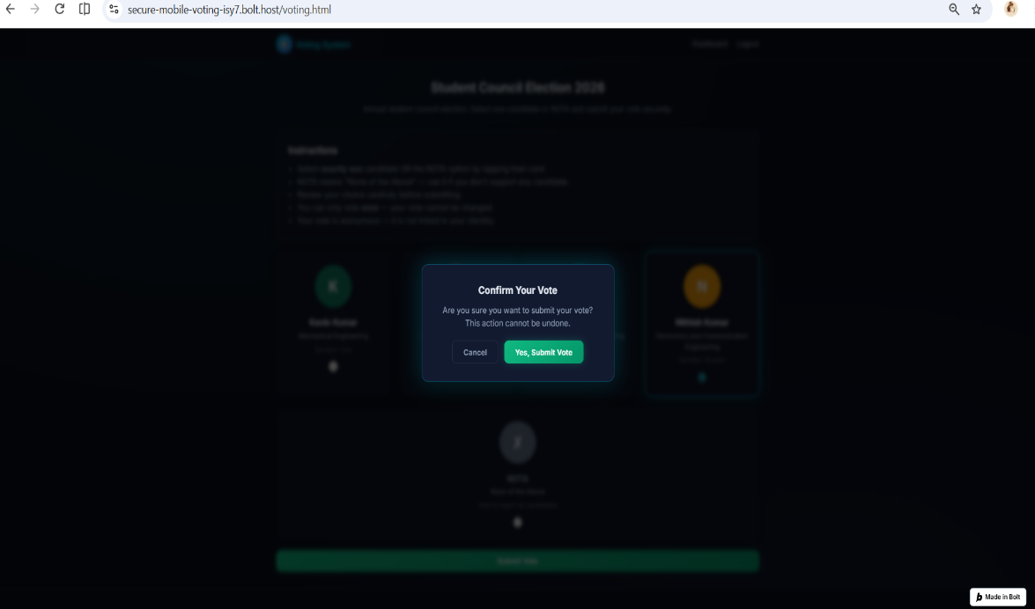
Figure 5: Vote confirmation and submission interface.
Figure 6 – Successful Vote Submission
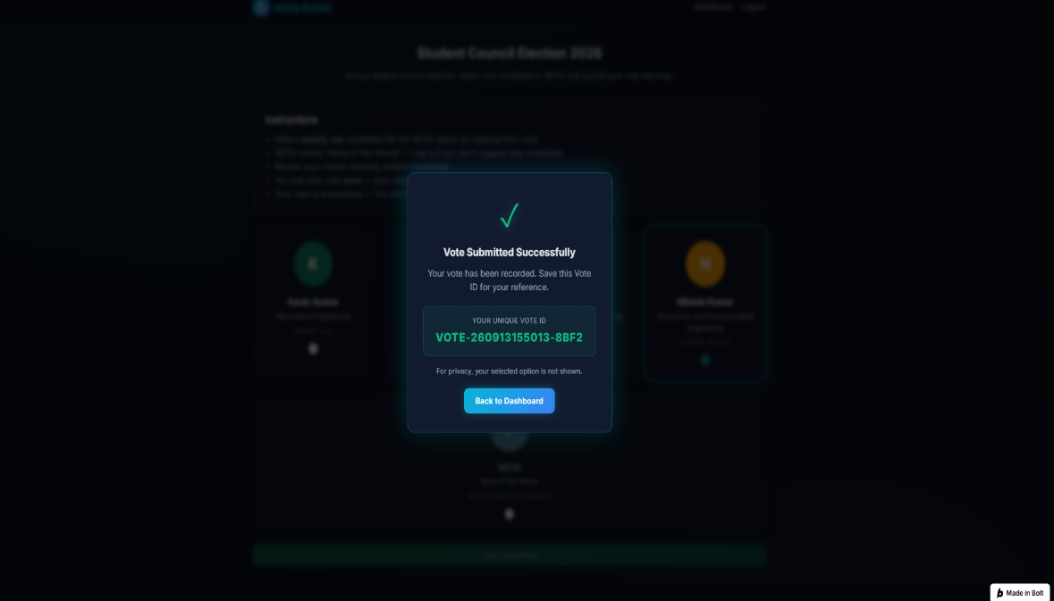
Figure 6: Confirmation displayed after successful vote submission.

Figure 7 – Admin Dashboard
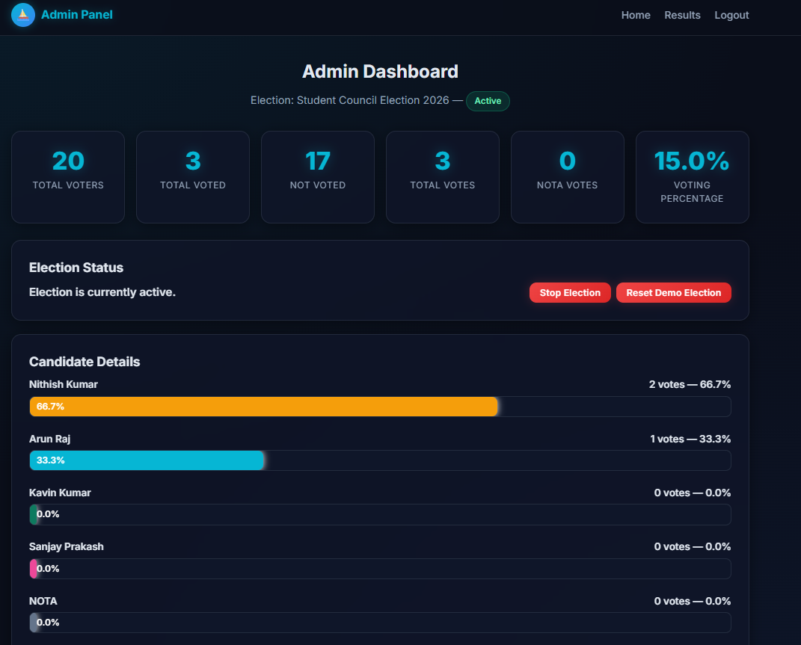.
Figure 7: Administrator dashboard displaying election and voting statistics
Figure 8 – Election Results
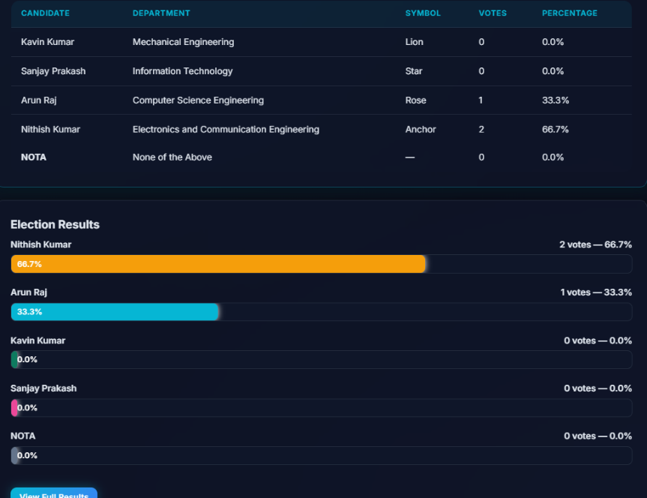
Figure 8: Election results and vote distribution interface.

Figure 9 – GitHub Repository
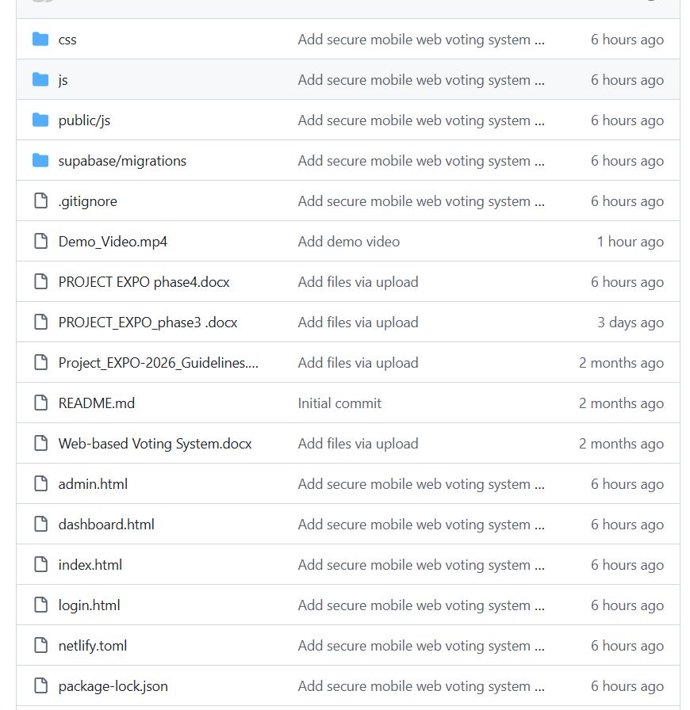
Figure 9: GitHub repository containing the project source code and project documentation.

FINAL CONCLUSION
The Secure Mobile Web-Based Remote Voting System was subjected to functional, performance, reliability, and debugging-oriented evaluation as part of the Testing & Validation Review.
The testing activities helped verify the major workflows of the prototype and identify areas requiring further improvement. The current version demonstrates the basic functionality of a secure web-based voting platform, while additional security validation, scalability testing, and extensive real-world testing are required before deployment in an actual election environment.

